Ex No: 5 Develop Application with gradle build automation and Spring tool

Aim: To develop application with gradle and Spring tool applications

Requirement:

* Eclipse IDE
* Java
* Gradle service components file
* Spring initializr
* Spring tool eclipse IDE

a) To develop a java application using gradle build automation process

Step 1: Create a Gradle project and override the methods from gradle distribution

2: Install the gradle service distributions and connect with the local folder and create the file

3: Edit the coding and design main() program to display the values using gradle, a build automation tool

Screenshot 1

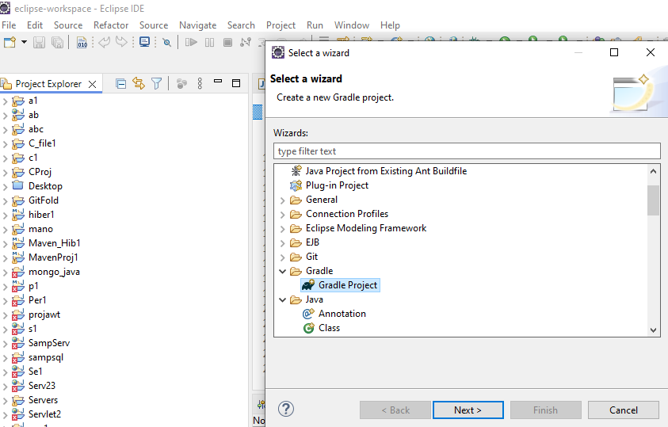

Screenshot 2

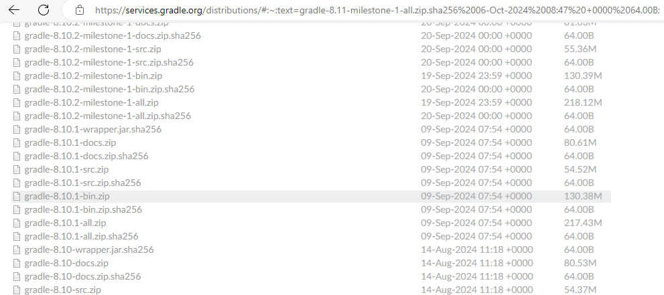

Screenshot3

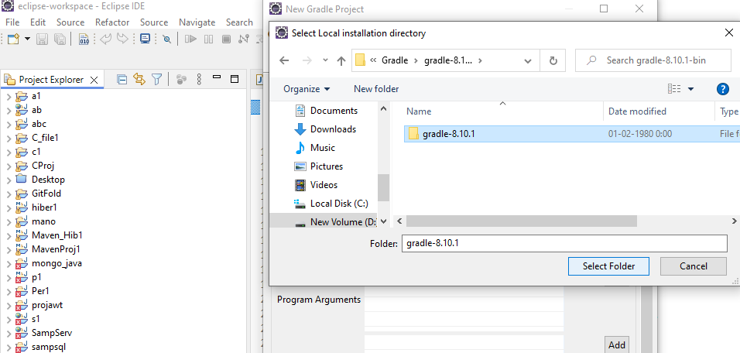

Screenshot 4

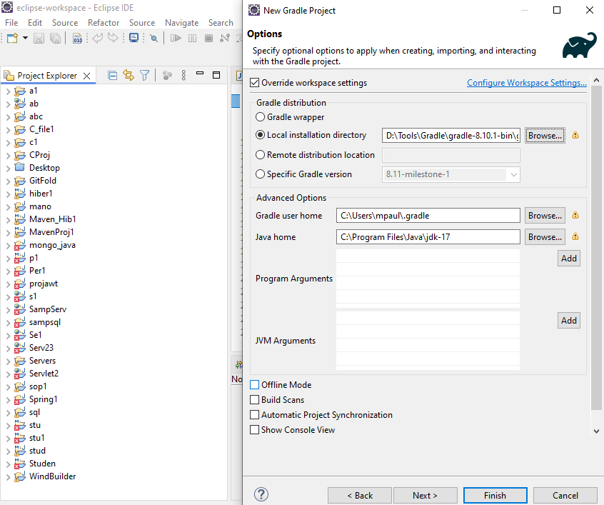

Screenshot 5

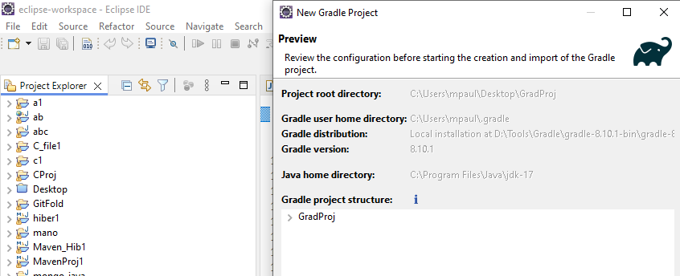

Screenshot 6

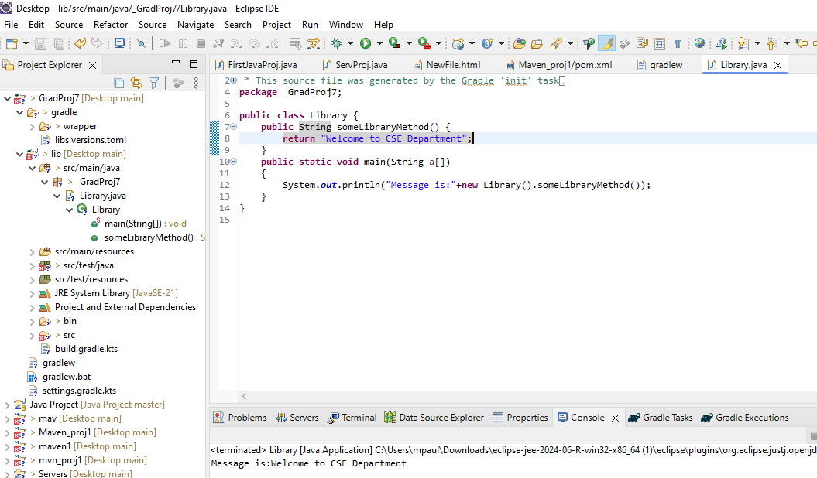

b) To develop an application using spring initializr with gradle build automation

Step:1 Go to spring initializr web site and prepare to download a file for gradle by checking its configuration

2: Add required dependencies and download the file and also unzip it in the given folder

3. Create a gradle installer with spring initializr

4. Add with existing gradle projects

5. Edit the application and run it

Screenshot 1

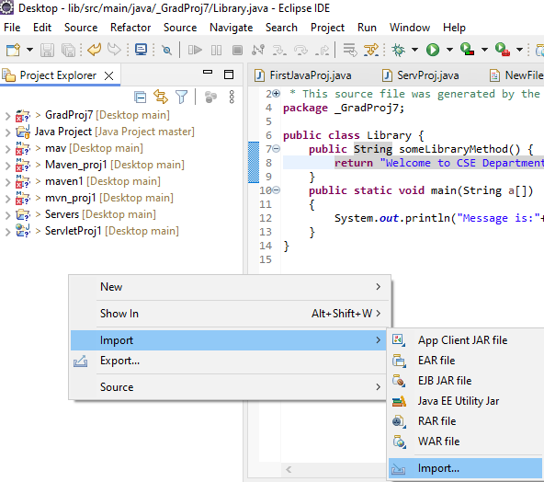

Screenshot 2

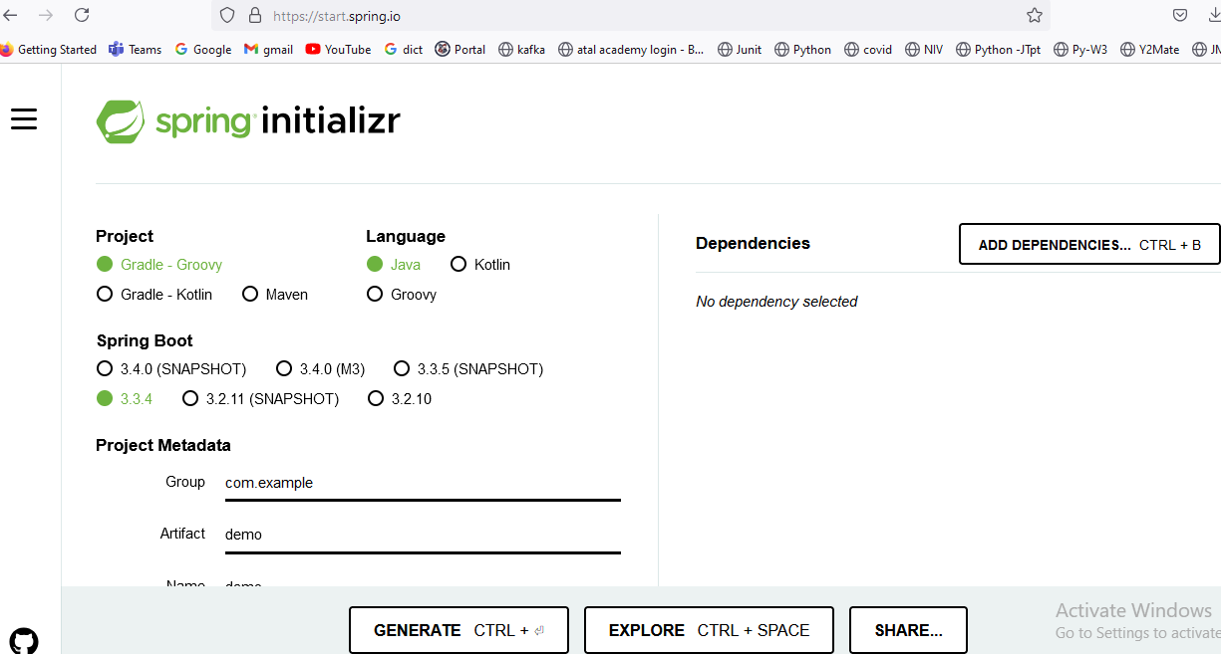

Screenshot 3

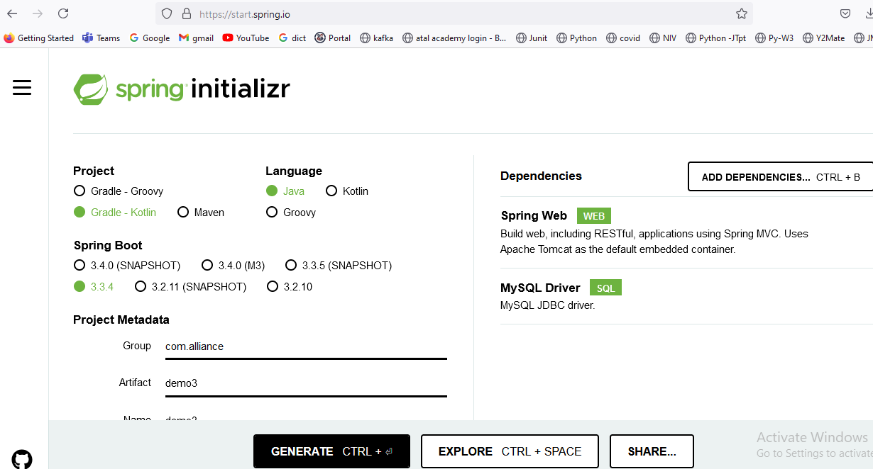

Screenshot 4

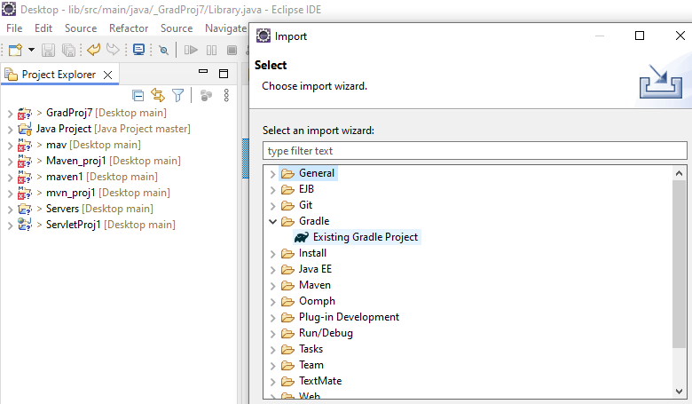

Screenshot 5

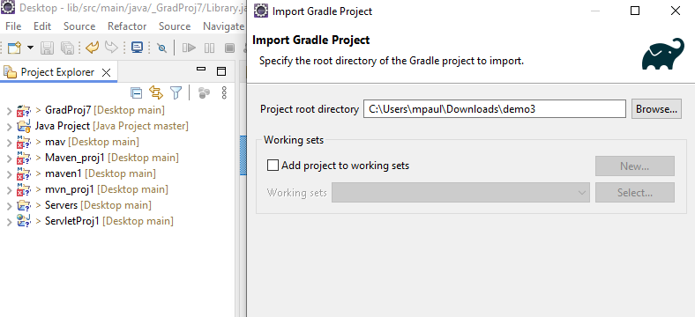

Screenshot 6

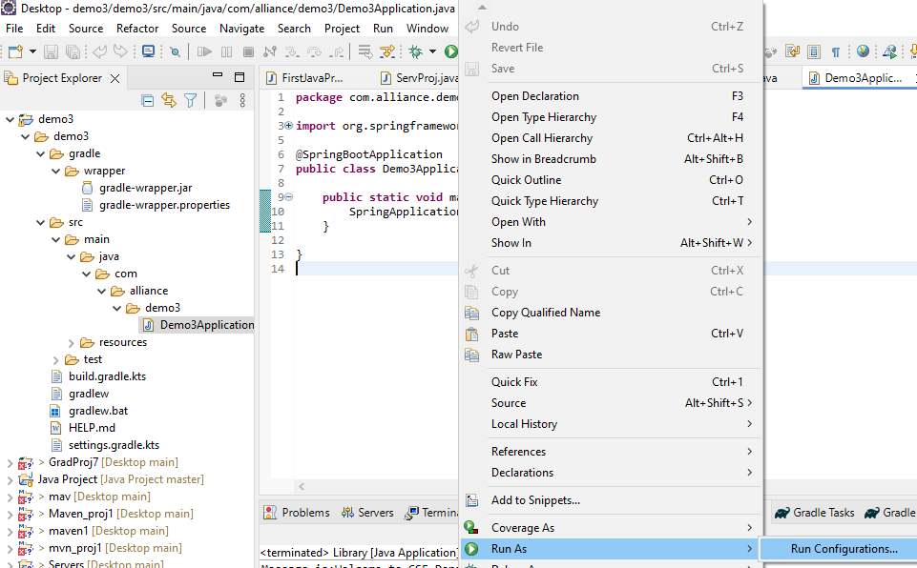

Screenshot 7

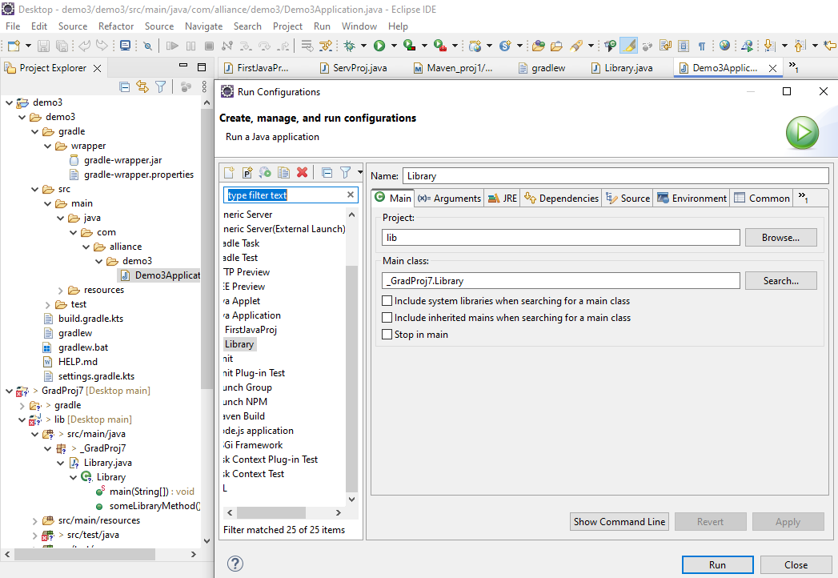

Screenshot 8

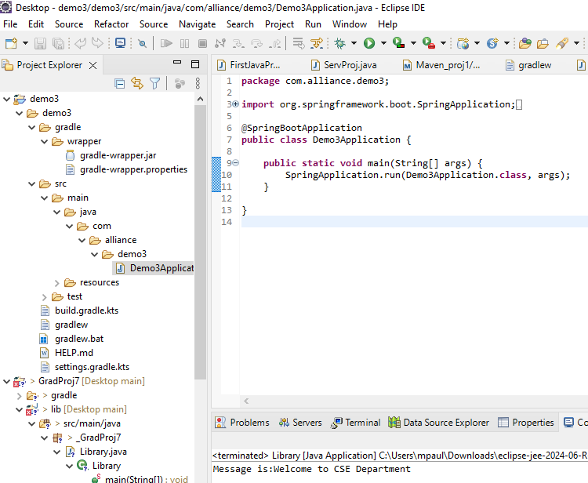

c) To develop an application using spring boot application programs

Step: 1 Create a Spring starter Project

2. Add all the configurations required for java execution

3. Give its available dependencies and version for the spring project

4. Create a java code in the same editor and execute the program

Screenshot 1

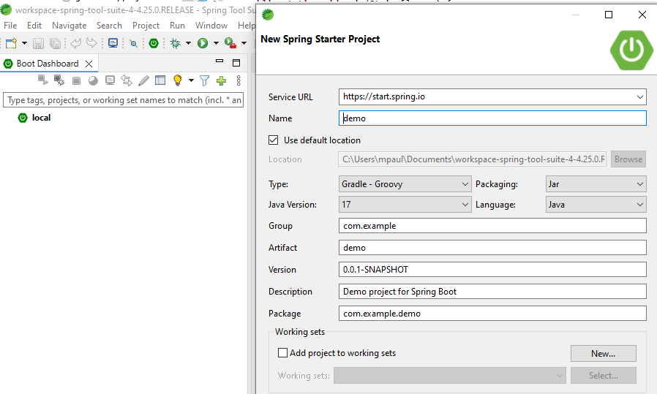

Screenshot 2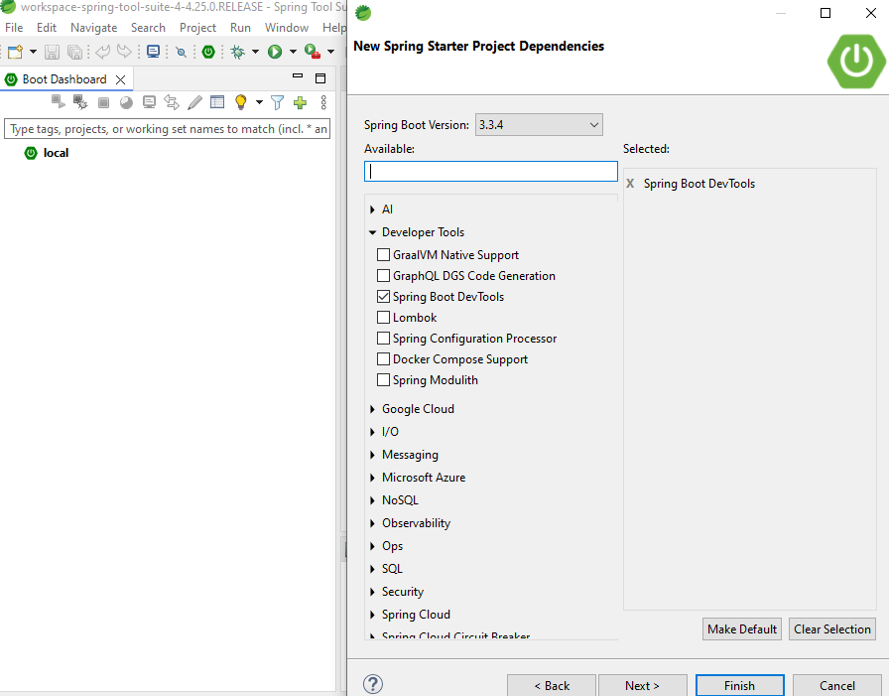

Screenshot 3

@SpringBootApplication

public class Proj1_3

{

public static void main(String args[])

{

SpringApplication.run(Proj1_3.class,args);

}

}

**Conclusion:**

Thus the program of implementing application using Maven / Gradle build automation and spring build automation was successfully implemented.